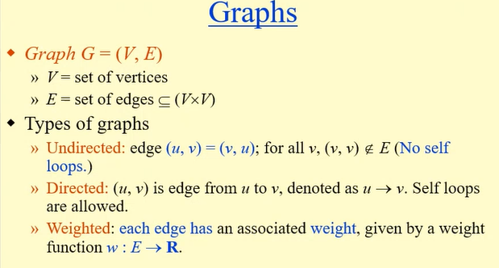
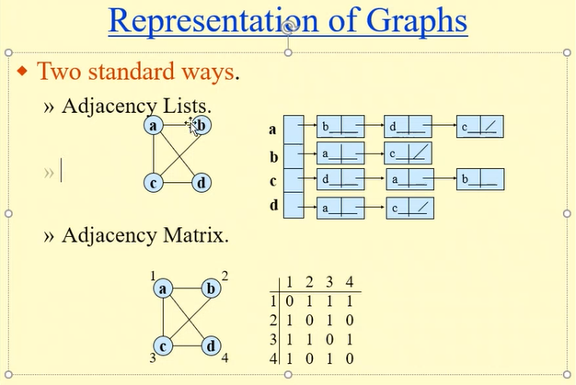

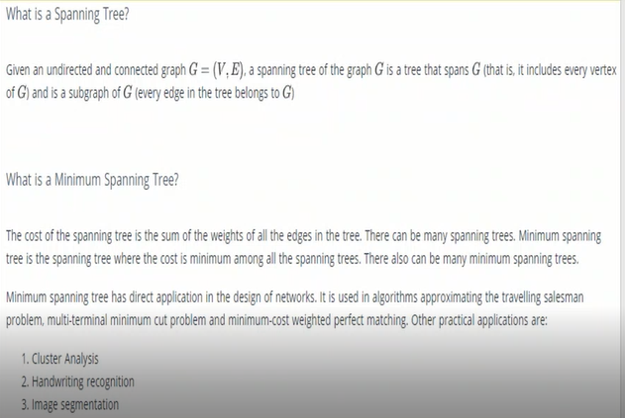

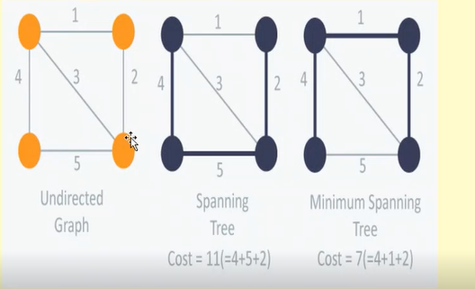

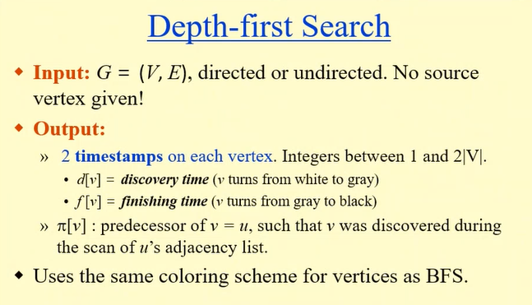
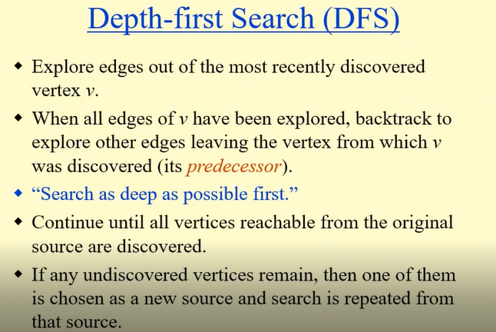
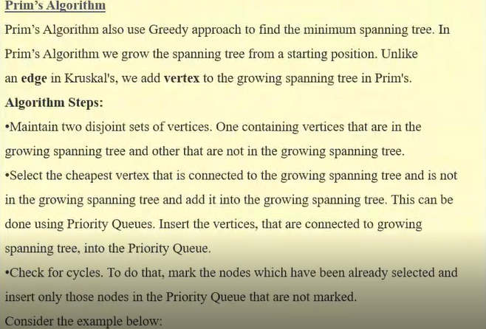

Depth first and Breadth first search

are two fundamental ways to go about searching relationships, its not just about graphs, we can be searching Strings( Certain amount of changes between Strings, sort of levenstein distance). We could be searching tree.
DFS and BFS are ways of searching they are not just about graphs, they are a way of approaching things.
DFS uses a stack either a stack we create or is the call stack where we use recursion.
This is why DFS can be done recursively.
BFS is implemented iteratively with a queue, a queue is FIFO and stack has
LIFO.
We Use DFS when we do Backtracking , complete search, exhaustive search possibitlites, finding all the paths.
Depth first search goes deep into the path and explore all of it and come back outwards and then decides to whether go on to a new path.

Breadth First search is great to check if there is a path between two nodes.
DFS to search the path between a node, it may get lost in the exhaustion of the graph.
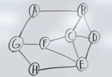

BFS is about going layer by layer.
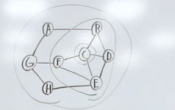
Its all about going wide, slowly increasing the distance from the start node, giving us breadth instead of depth.
BFS is good to find something levels away from something. It could be a tree, it doesnt have to be graph.
So if we wanna do level order traversal of a tree, bfs is our friend

BFS goes wide, it doesnt go deep. BFS priority is to go level by level.
DFS is to go deep into his path comeback and deep again and …

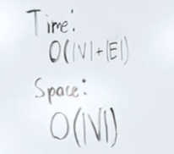
V: Vertices
E: edges

For dfs, for stack, if we doing a tree and if its balanced we only gonna have 0(h) complexity. Cuz we only caring about the items we have on the stack on max. If our tree is balanced we would only have the max the height of the tree in the stack.
If its unbalanced its gonna be 0(v). So it depends on what data structure you working with.

Code:
we need a seen Hashset so we dont reprocess items and cause a cycle in our traversal. Hashset is a set of unique items. So we only process nodes that we havent seen
-----
Prims Vs Dijkstra Algorithm
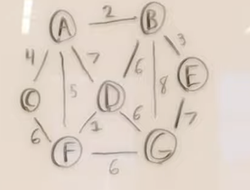

Both greedy algorithms operate on graph, prims algorithms tries to find the minimum spanning tree and dijkstra algorithm find the shortest path tree.

They both are greedy algo, they both operate on graphs, they both create trees.
At the end of the day, they have different goals and their greedy strategy optimize for different things.

---Dijsktra algorithm

is a Single shortest path problem, if a weighted graph is given, we need to find the shortest path from some source to all other vertex.
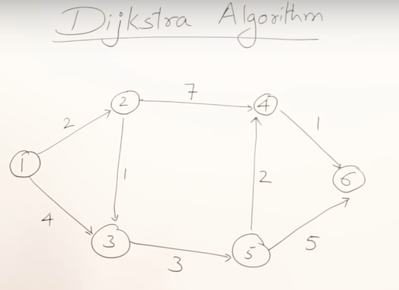

Since we are finding shortest path, its a minimization problem.
A minimization problem is a optimization problem.
Optimization problem can be solved by using greedy method.
Greedy method says that a problem should be solved in stages by taking one step at a time and considering one input at a time to get an optimal solution.
Greedy method we have predefined procedures, we follow the procedure to get an optimal solution.
Dijkstra algorithm gives a procedure to give an optimal solution I.e shortest path.

Dijkstra works on directed and undirected graph.
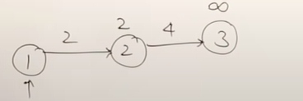

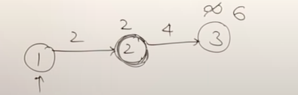

Relaxation:
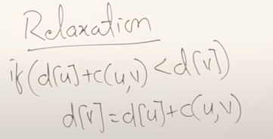

Solution:
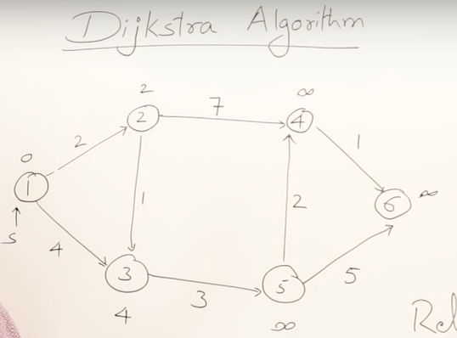

1)From source explore all nodes that are directed from source node, and set all other nodes which are not directed from source as infinity.
2) select the nodes with lowest cost.
3)So its (2) explored all the nodes from(2) and perform relaxation.
4)After all nodes from some node is explored add that to visited.
Repeat step 2 and 3
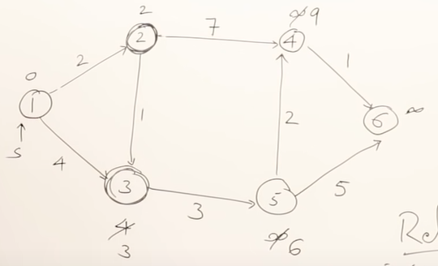

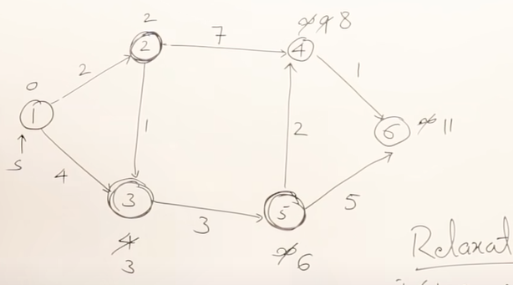

so (4) and (6) are left
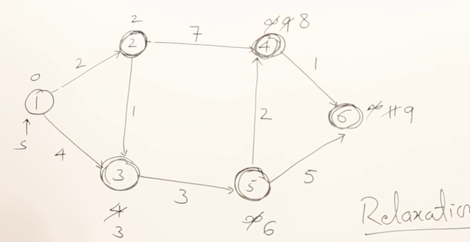

Djikstra algorithm is finding shortest path to all the veritces.
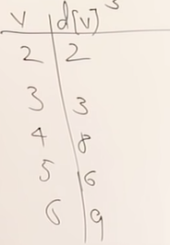

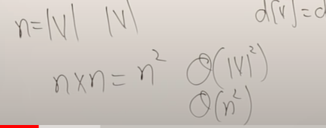
worst case time: for a complete graph. Where a node is connected to all nodes.

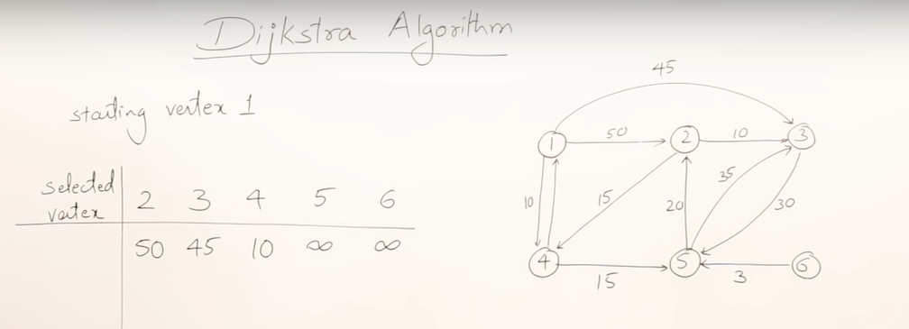
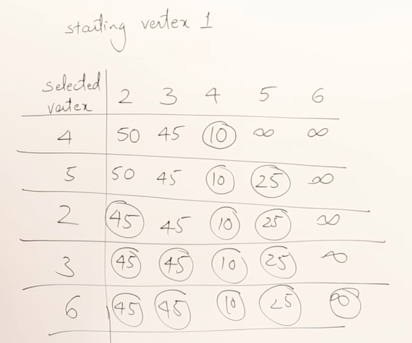

Drawback of Dijktra algorithm.
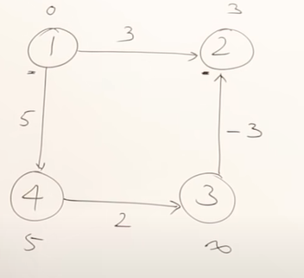

Prims and kruskal algorithm-- Greedy Method
Minimum cost spanning tree
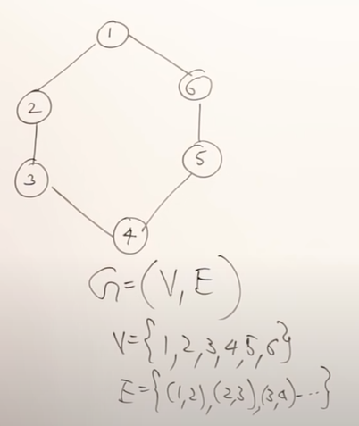

Spanning tree is a subgraph of a graph, which means I should take the subset of edges and all vertices.
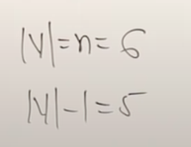

No cycle.
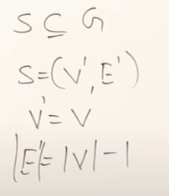

No of combinations that can be form is 6Combinatorics5
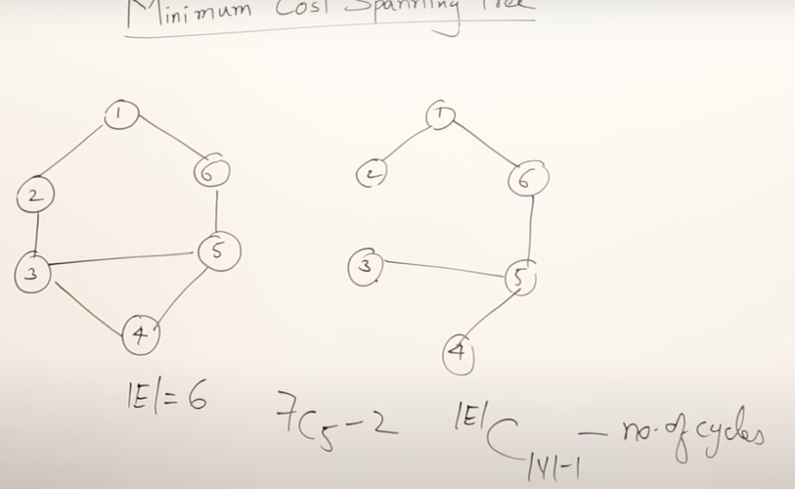

Two algorithms To find Minimum Cost spanning Tree:
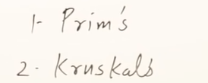

Prims algorithm:
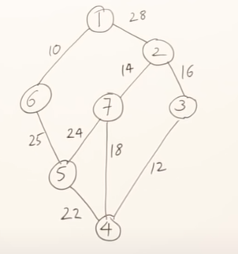

STEP 1. From the graph you select a minimum cost edge.
STEP 2. Follow Step 1 and make sure the minimum cost edge is connected to already selected edge.
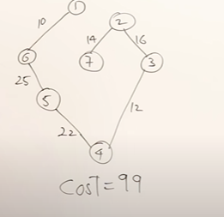

Kruskals algorithm.

STEP 1. Select the minimum cost edge
STEP 2. Follow step 1 and Draw out all edges but make sure it doesnt form a cycle.
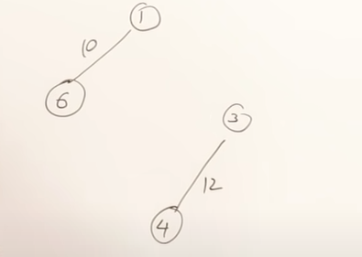
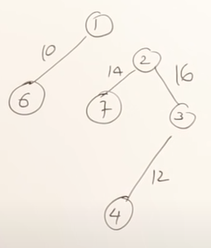
>>>

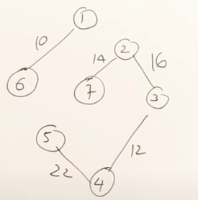
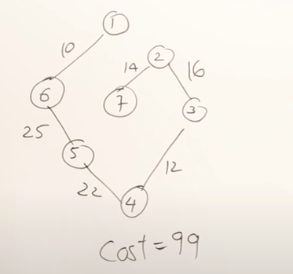
>>>

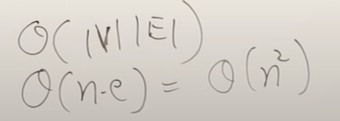
Kruskals algorithm.

How kruskals is improved?
When we have to always select minimum cost edge theres a datastructure that will always give u a min value I.e minHeap.whenever u delete a value u get a next min value or edge

So in minHeap whenever u delete the time taken
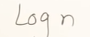
and how many times u need to perform ?

I.e is no of vertices so
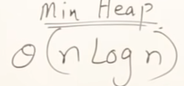

Kruskal vs Prims
Unlike Prims that looks for minimum cost edge that is connected to already selected vertices.
Kruskal algorithm for edge disjoint graph, finds the minimum spanning tree for all disjoint component

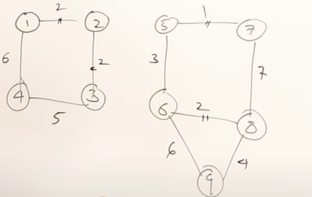
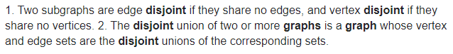

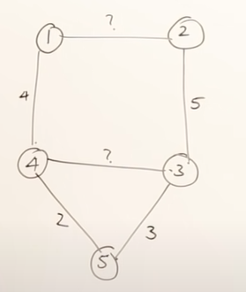
If we have two edges whose weight is unknown in a spanning tree?

So the edge(4,3) maybe selected after selecting this two I.e e(4,5) and e(5,3).

So the minimum value must be greater than 2,3 so possibly 4.

Likewise e(1,2) could be a 6. cuz its selected at
last.

Another e.g
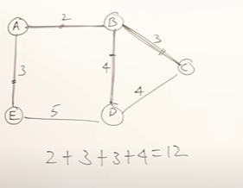

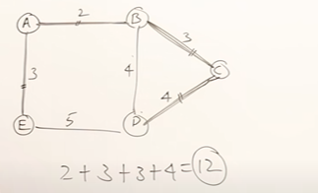

OR

Above you have two minimum spanning tree, but the cost is the same.

